**Data Warehousing and Data Mining.**

**Name : Antuley Aman Siraj.**

**Roll No. : 23CO25.**

**Class : TE-CO**

**Batch : 01**

**Experiment - 08**

**Aim:** Implementation of any one Hierarchical Clustering method

**Theory:**

**Hierarchical Clustering:**

Hierarchical clustering is another unsupervised machine learning algorithm, which is used to group the unlabeled datasets into a cluster and also known as **hierarchical cluster analysis** or HCA. In this algorithm, we develop the hierarchy of clusters in the form of a tree, and this tree- shaped structure is known as the **dendrogram**.

# **1.Divisive Hierarchical Clustering: -**

**Divisive Hierarchical Clustering** is also termed as a top-down clustering approach. In this technique, entire data or observation is assigned to a single cluster. The cluster is further split until there is one cluster for each data or observation.

# **2.Agglomerative Hierarchical Clustering: -**

**Agglomerative Hierarchical Clustering** is popularly known as a bottom-up approach, wherein each data or observation is treated as its cluster. A pair of clusters are combined until all clusters are merged into one big cluster that contains all the data.

# **Agglomerative Hierarchical clustering Algorithm:**

Let X = {x1, x2, x3, ..., xn} be the set of data points.

1. Begin with the disjoint clustering having level L(0) = 0 and sequence number m = 0.
2. Find the least distance pair of clusters in the current clustering, say pair (r), (s), according to d[(r), (s)] = min d[(i), (j)] where the minimum is over all pairs of clusters in the current clustering.
3. Increment the sequence number: m = m +1. Merge clusters (r) and (s) into a single cluster to form the next clustering m. Set the level of this clustering to L(m) = d[(r), (s)].
4. Update the distance matrix, D, by deleting the rows and columns corresponding to clusters (r) and (s) and adding a row and column corresponding to the newly formed cluster. The distance between the new cluster, denoted (r,s) and old cluster(k) is defined in this way: d[(k), (r,s)] = min (d[(k),(r)], d[(k),(s)]).
5. If all the data points are in one cluster, then stop, else repeat from step 2).

**Divisive Hierarchical clustering -** It is just the reverse of Agglomerative Hierarchical approach.

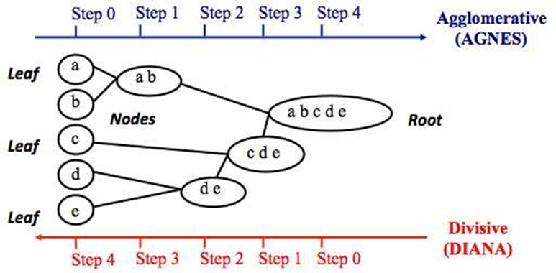

**Program:**

**import matplotlib.pyplot as plt**

**import pandas as pd**

**import scipy.cluster.hierarchy as sc**

**from sklearn import datasets**

**from sklearn.cluster import AgglomerativeClustering**

**# Import iris data**

**iris = datasets.load_iris()**

**iris_data = pd.DataFrame(iris.data)**

**iris_data.columns = iris.feature_names**

**iris_data["flower_type"] = iris.target**

**iris_data.head()**

**# Visualise the classes**

**iris_X = iris_data.iloc[:, [0, 1, 2, 3]].values**

**iris_Y = iris_data.iloc[:, 4].values**

**plt.figure(figsize=(10, 7))**

**plt.scatter(**

**iris_X[iris_Y == 0, 0], iris_X[iris_Y == 0, 1], s=100, c="blue", label="Type 1"**

**)**

**plt.scatter(**

**iris_X[iris_Y == 1, 0], iris_X[iris_Y == 1, 1], s=100, c="yellow", label="Type 2"**

**)**

**plt.scatter(**

**iris_X[iris_Y == 2, 0], iris_X[iris_Y == 2, 1], s=100, c="green", label="Type 3"**

**)**

**plt.legend()**

**plt.show()**

**# Plot dendrogram**

**plt.figure(figsize=(10, 7))**

**plt.title("Dendrograms")**

**sc.dendrogram(sc.linkage(iris_X, method="ward"))**

**plt.title("Dendrogram")**

**plt.xlabel("Sample index")**

**plt.ylabel("Euclidean distance")**

**# Agglomerative clustering (use 'metric' instead of 'affinity')**

**cluster = AgglomerativeClustering(n_clusters=3, metric="euclidean", linkage="ward")**

**cluster.fit(iris_X)**

**labels = cluster.labels_**

**print(labels)**

**# Plot clustered points**

**plt.figure(figsize=(10, 7))**

**plt.scatter(**

**iris_X[labels == 0, 0], iris_X[labels == 0, 1], s=100, c="blue", label="Cluster 1"**

**)**

**plt.scatter(**

**iris_X[labels == 1, 0], iris_X[labels == 1, 1], s=100, c="yellow", label="Cluster 2"**

**)**

**plt.scatter(**

**iris_X[labels == 2, 0], iris_X[labels == 2, 1], s=100, c="green", label="Cluster 3"**

**)**

**plt.legend()**

**plt.show()**

**Output :**

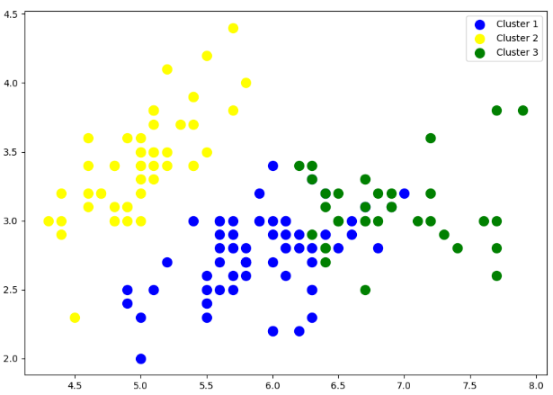

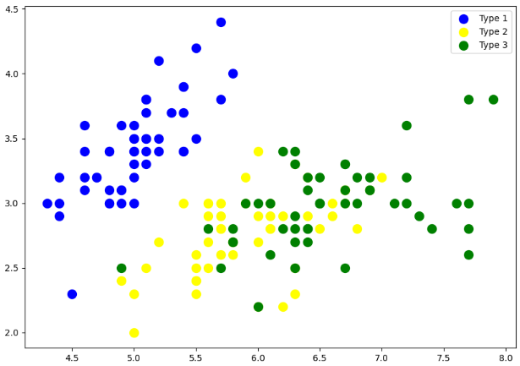

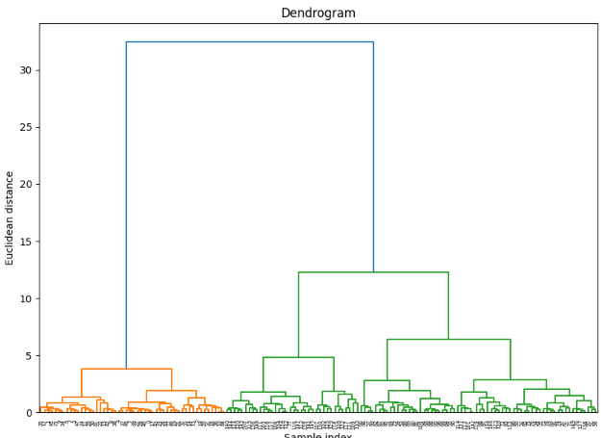

**Conclusion:**

Thus, we successfully implemented the Hierarchical Clustering method.